**School of Computer Science**

**UNIVERSITY OF PETROLEUM AND ENERGY STUDIES**

**DEHRADUN, UTTARAKHAND**



**System Provisioning and Configuration Management**

**Lab File (2021-2025)**

# **6th Semester**

|  |  |
| --- | --- |
| *Submitted To:*  ***Dr. Hitesh Kumar Sharma*** | *Submitted By:*  *Abhay Chaudhary*  *(500090987)*  *B Tech CSE*  *DevOps[6th Semester]*  *R2142210016*  *Batch - 1* |

**Lab Exercise 1– Install Terraform on Windows**

Installing Terraform on Windows requires you to download the correct Terraform package, unpack, and execute it via the CLI. Follow the instructions below to ensure you do not miss any steps.

Download Terraform File for Windows

To find the latest version of Terraform for Windows:

1. Browse to the Download Terraform page.

2. Select the Windows tab under the Operating System heading. The latest version is preselected.

3. Choose the binary to download. Select 386 for 32-bit systems or AMD64 for 64-bit systems. Choose the download location for the zip file if the download does not start automatically.

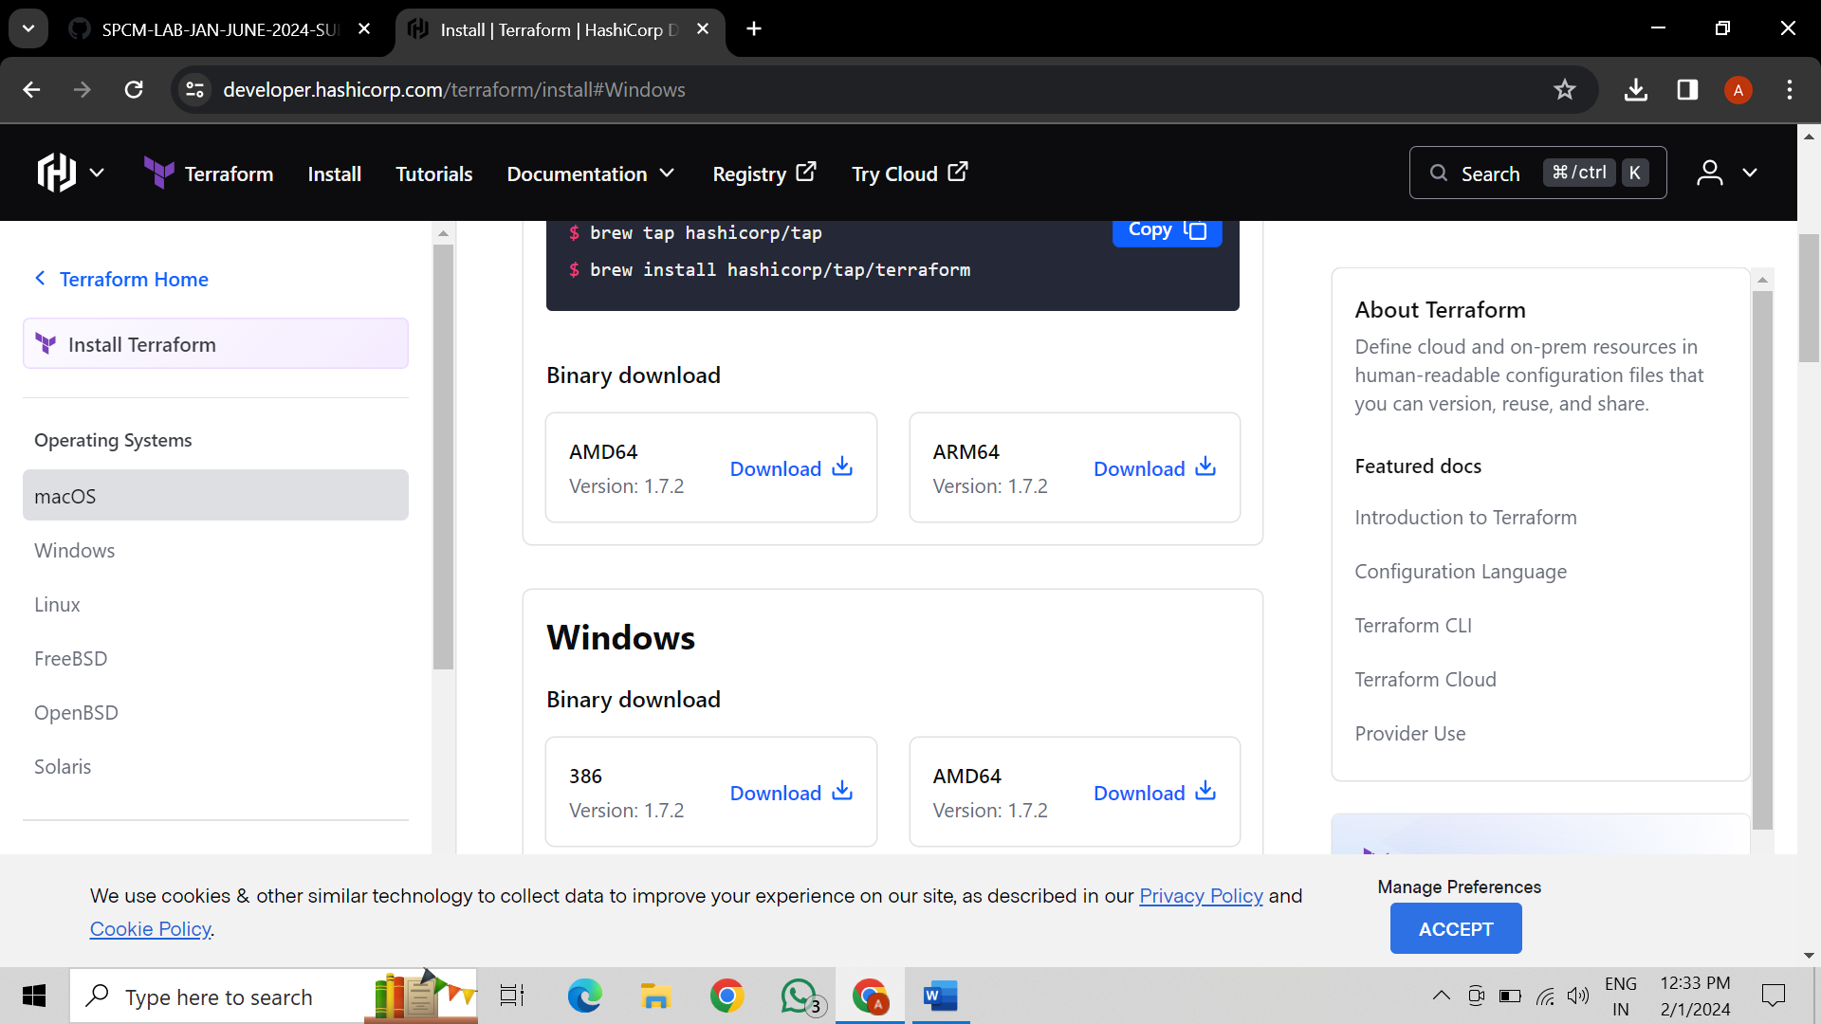

4. Unzip the downloaded file. For example, use the C:\terraform path. Remember this location so you can add the path to the environment variables.

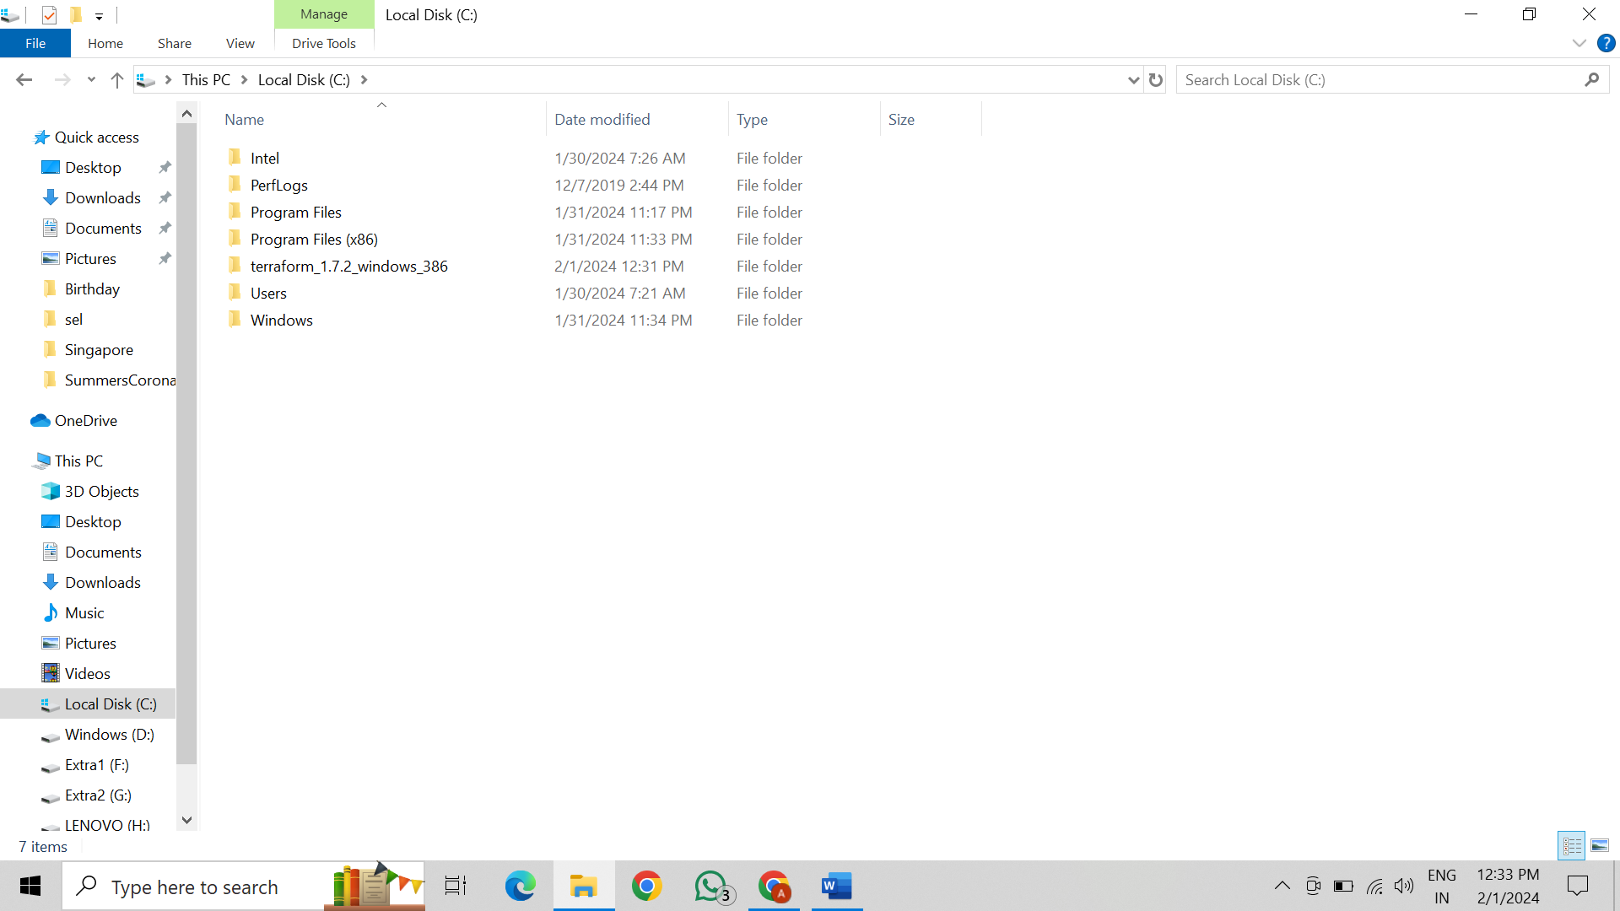

Add Terraform Path to System Environment Variables To add the Terraform executable to the system's global path:

1. Open the start menu, start typing environment and click Edit system environment variables. The System Properties window opens.

2. Click the Environment Variables... button.

3. Select the Path variable in the System variables section to add terraform for all accounts. Alternatively, select Path in the User variables section to add terraform for the currently logged-in user only. Click Edit once you select a Path.

4. Click New in the edit window and enter the location of the Terraform folder.

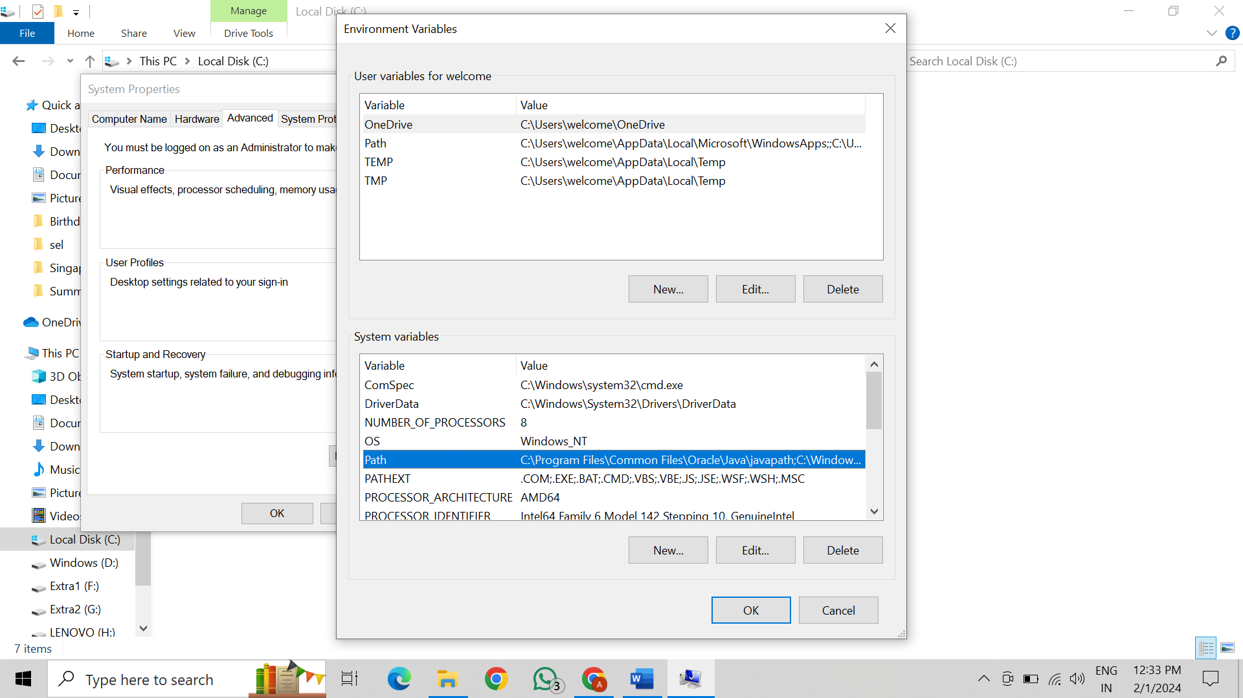 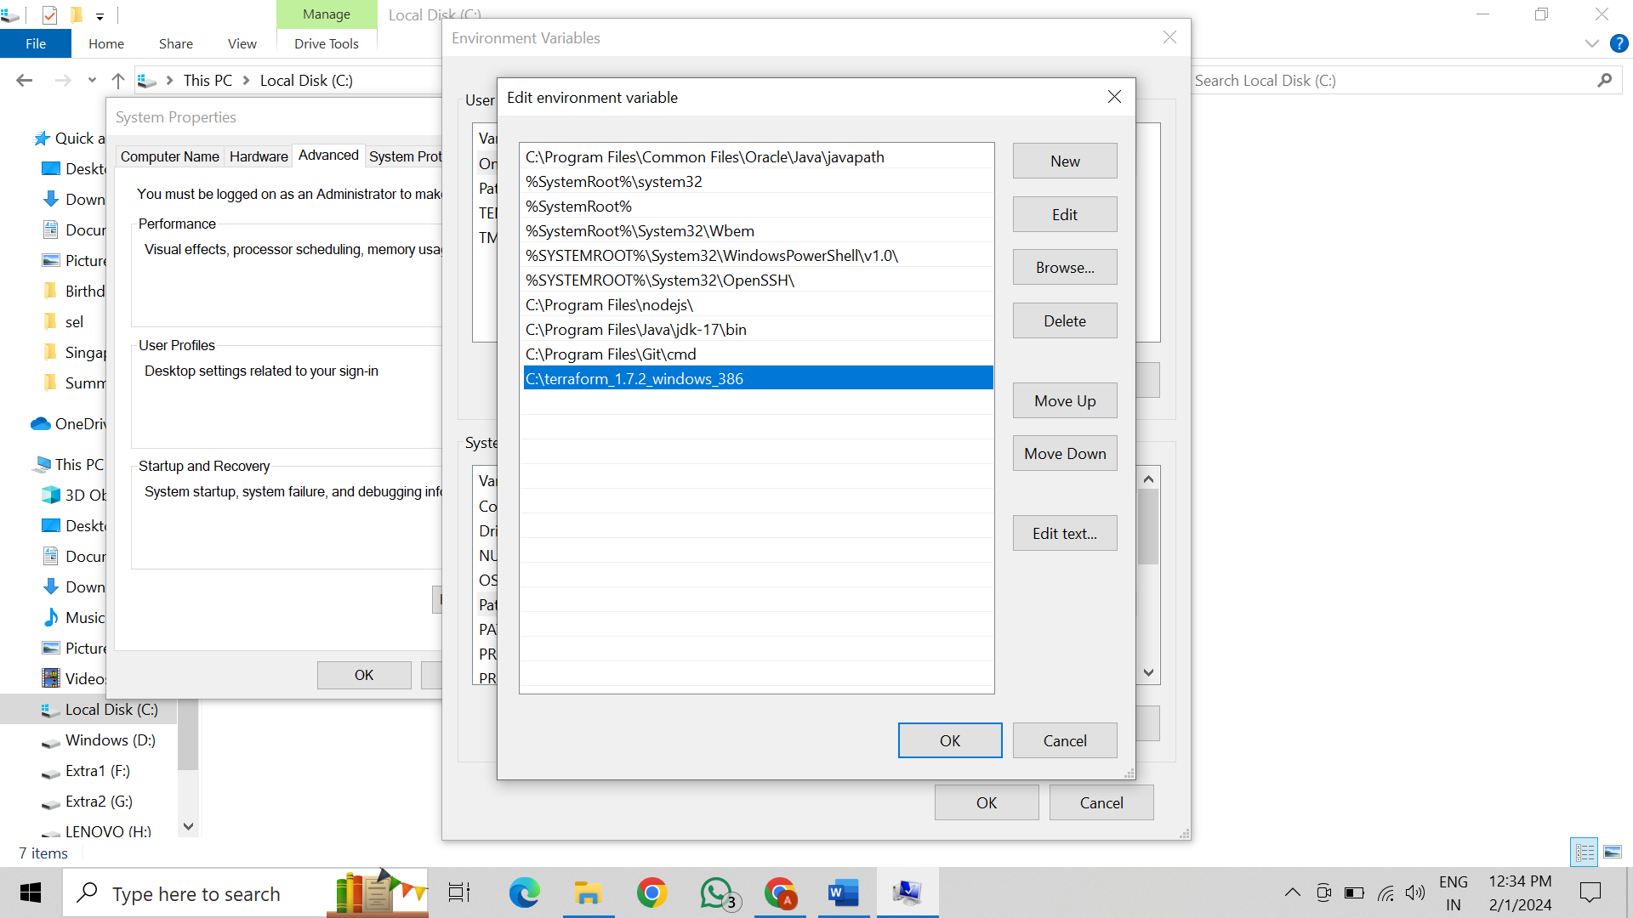

Verify Windows Terraform Installation To check the Terraform global path configuration:

1. Open a new command-prompt window.

2. Enter the command to check the Terraform version: terraform -version

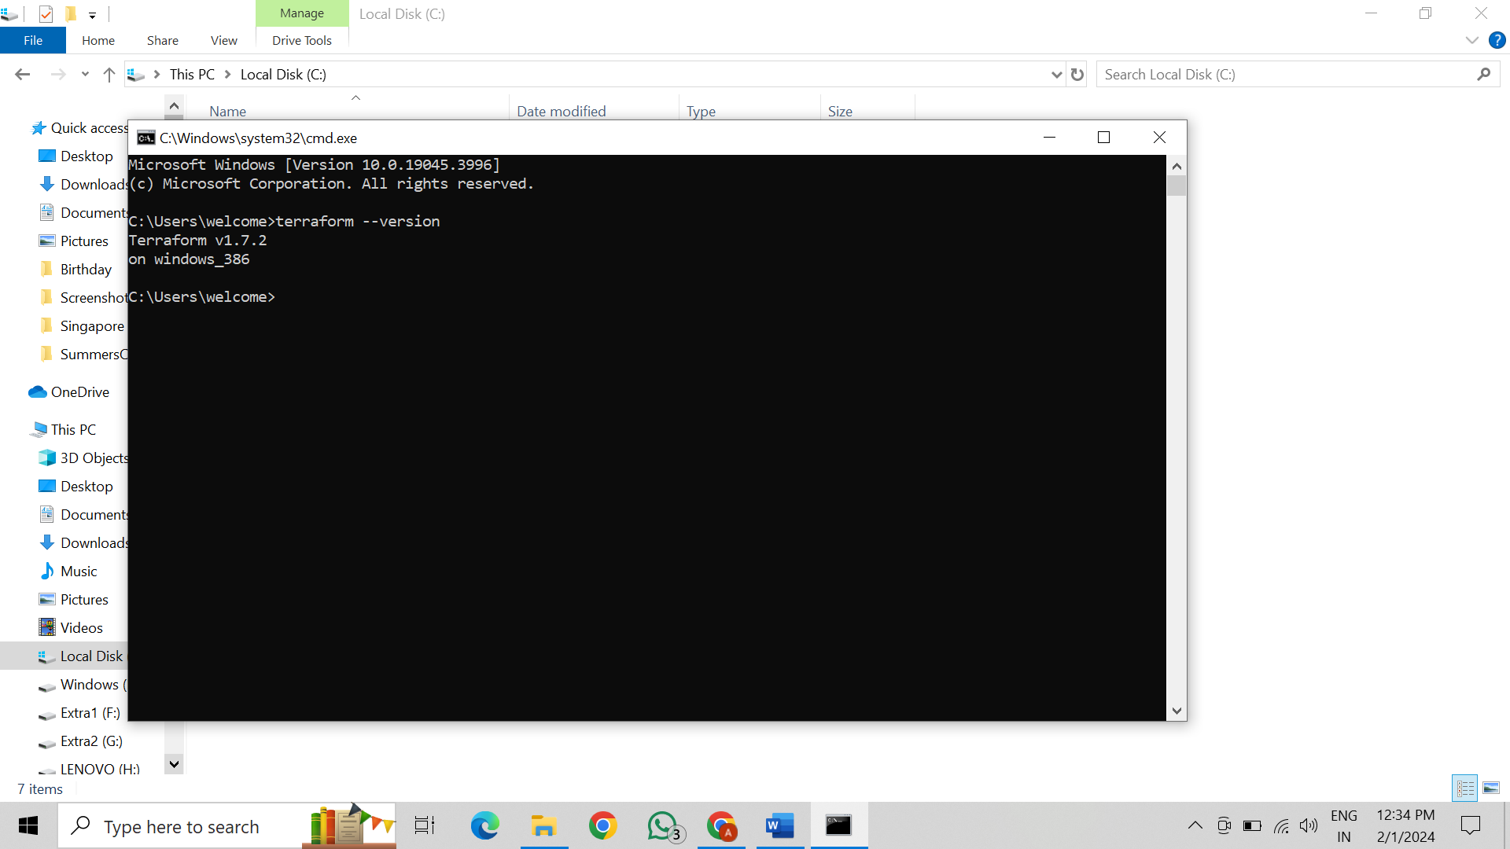

**Lab Exercise 2– Terraform AWS Provider and IAM User Setting**

AWS Credentials: Ensure you have AWS credentials (Access Key ID and Secret Access Key) configured. You can set them up using the AWS CLI or by setting environment variables.

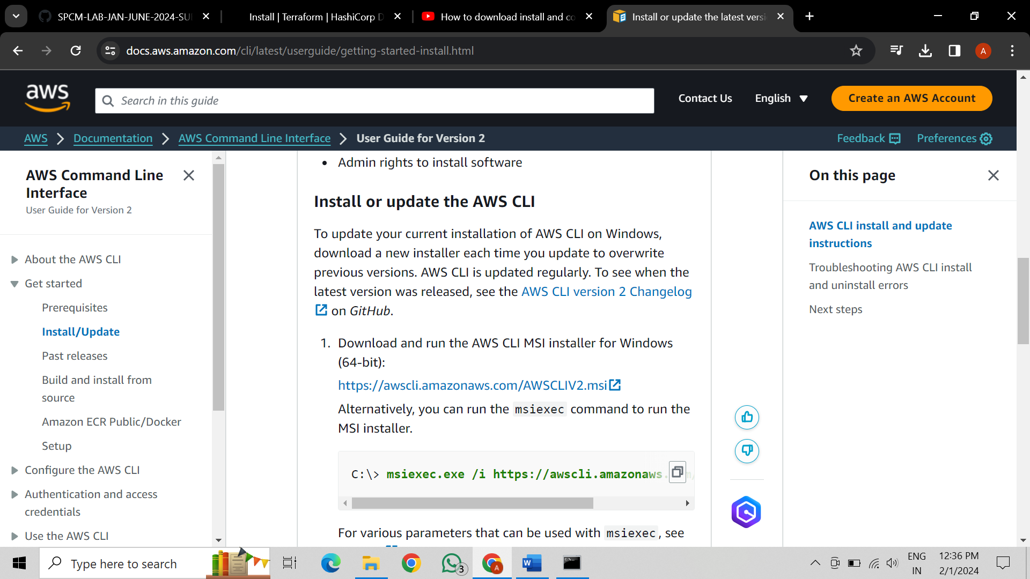

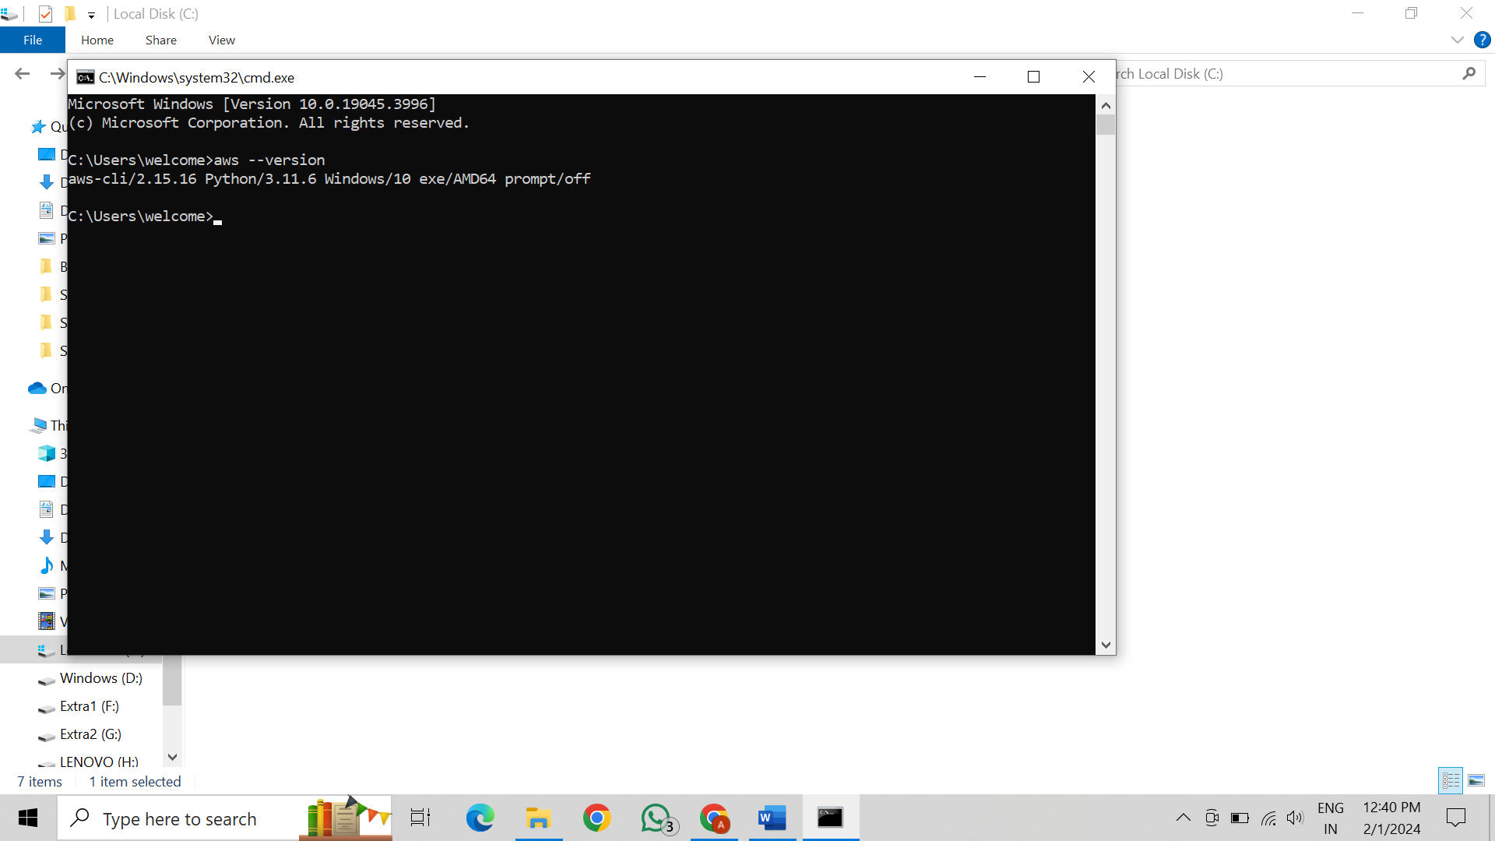

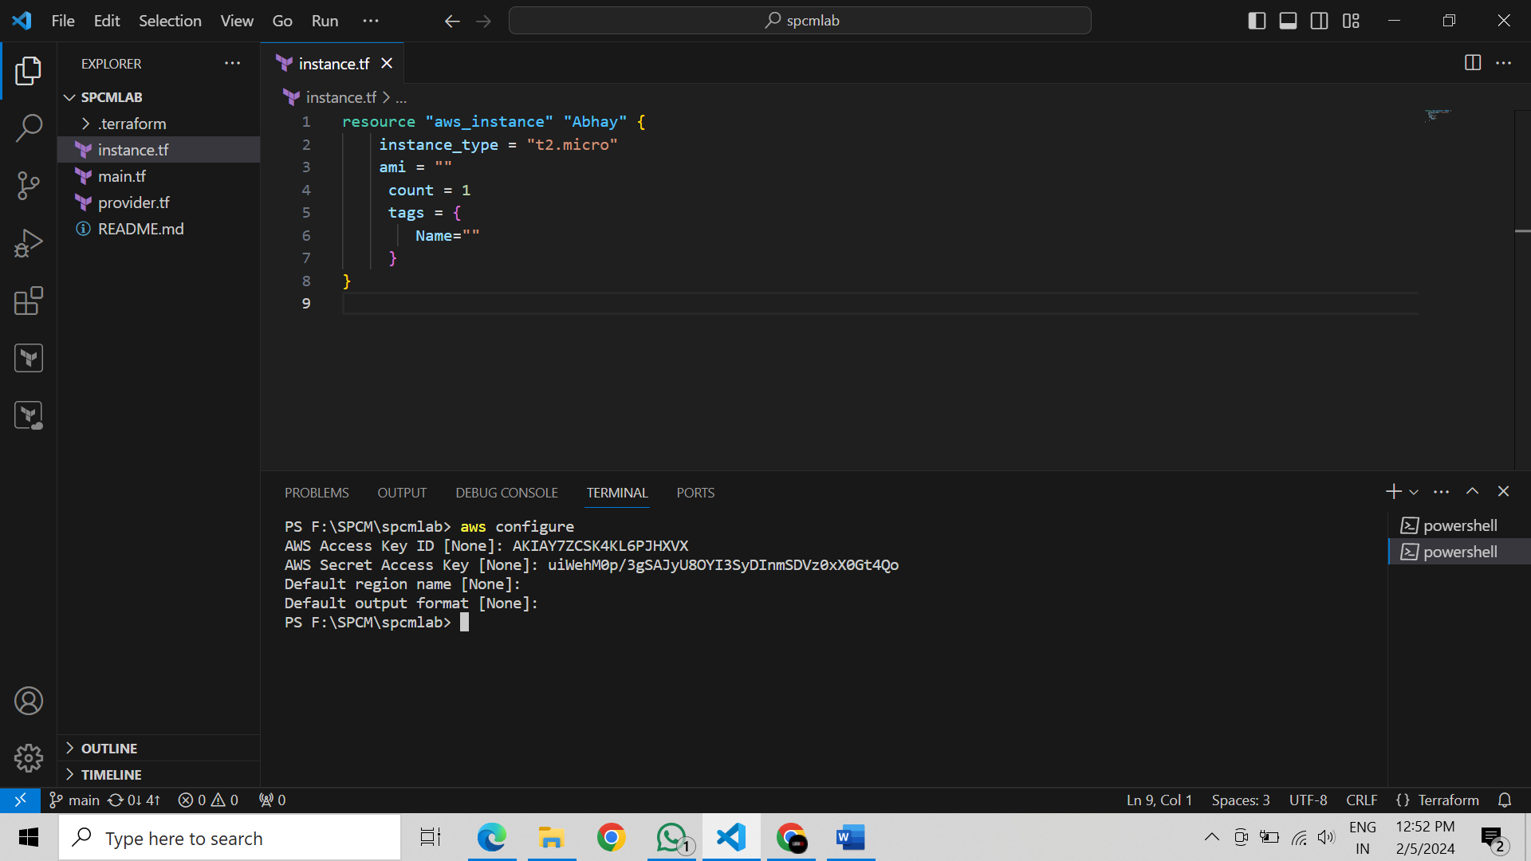

Exercise Steps: Step

1: Create a New Directory: Create a new directory for your Terraform configuration:

2: Create Terraform Configuration File (main.tf): Create a file named main.tf with the following content:

This script defines an AWS provider and provisions an EC2 instance.

3: Initialize Terraform: Run the following command to initialize your Terraform working directory:

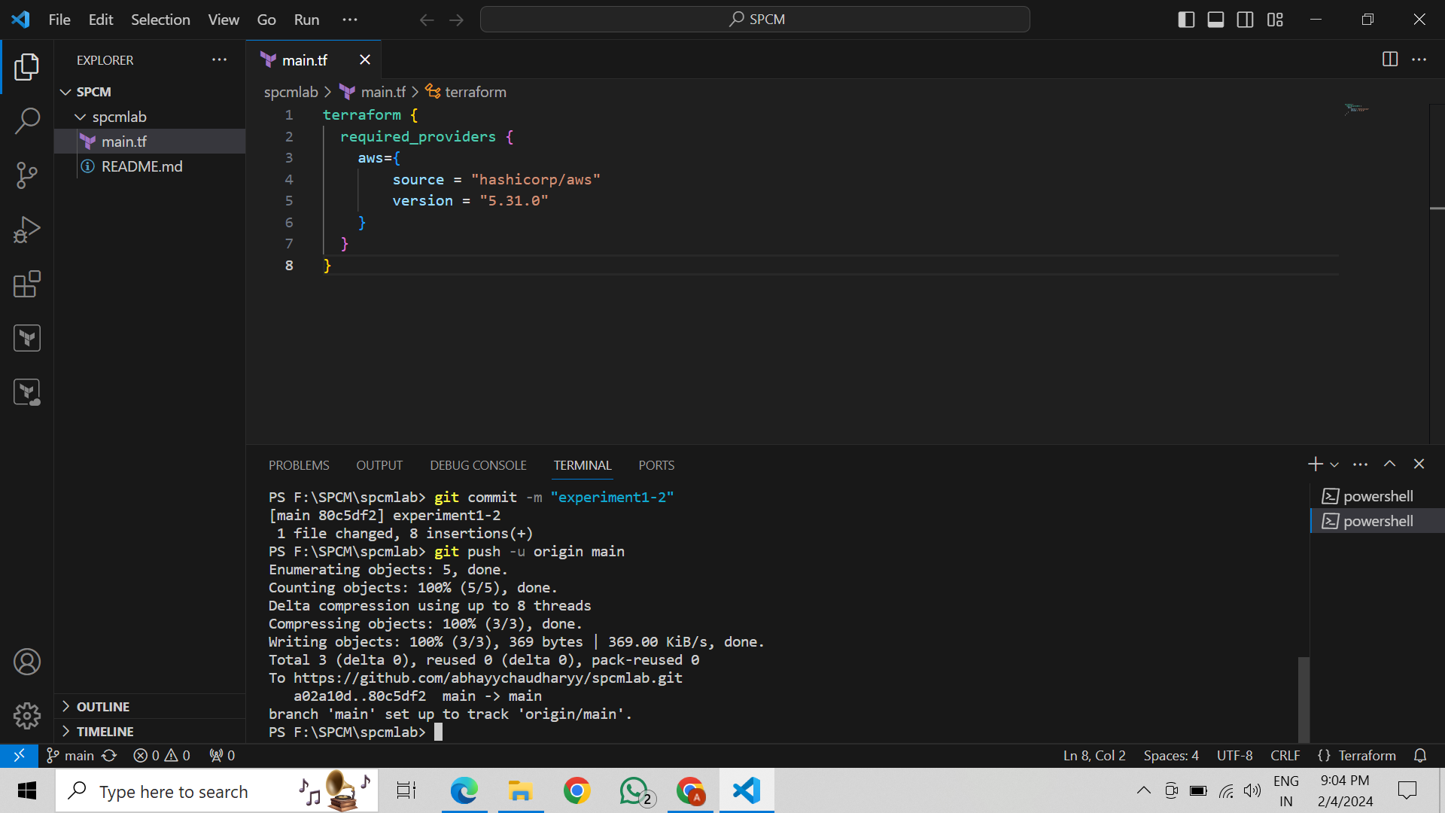

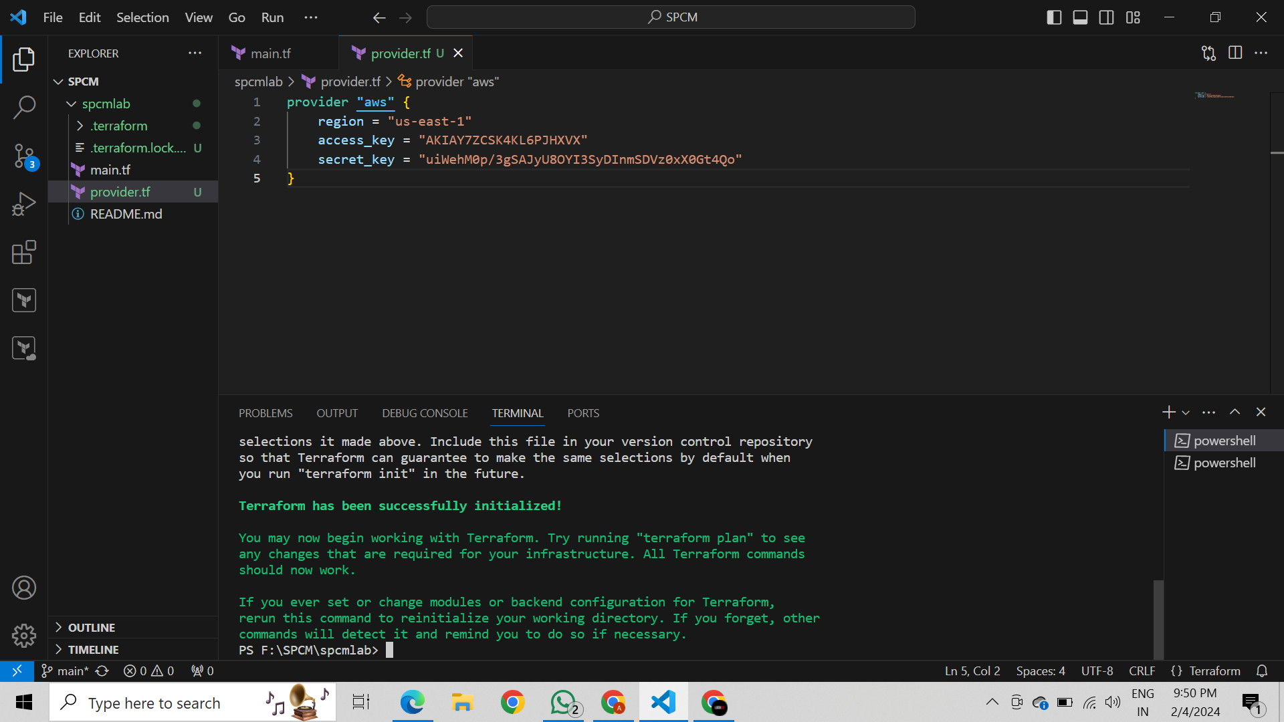

**Lab Exercise 3–Provisioning an EC2 Instance on AWS**

Exercise Steps:

1: Create a New Directory: Create a new directory for your Terraform configuration:

2: Create Terraform Configuration File (main.tf): Create a file named main.tf with the following content:

This script defines an AWS provider and provisions an EC2 instance.

3: Initialize Terraform: Run the following command to initialize your Terraform working directory:

4: Create Terraform Configuration File for EC2 instance (instance.tf): Create a file named instnace.tf with the following content:

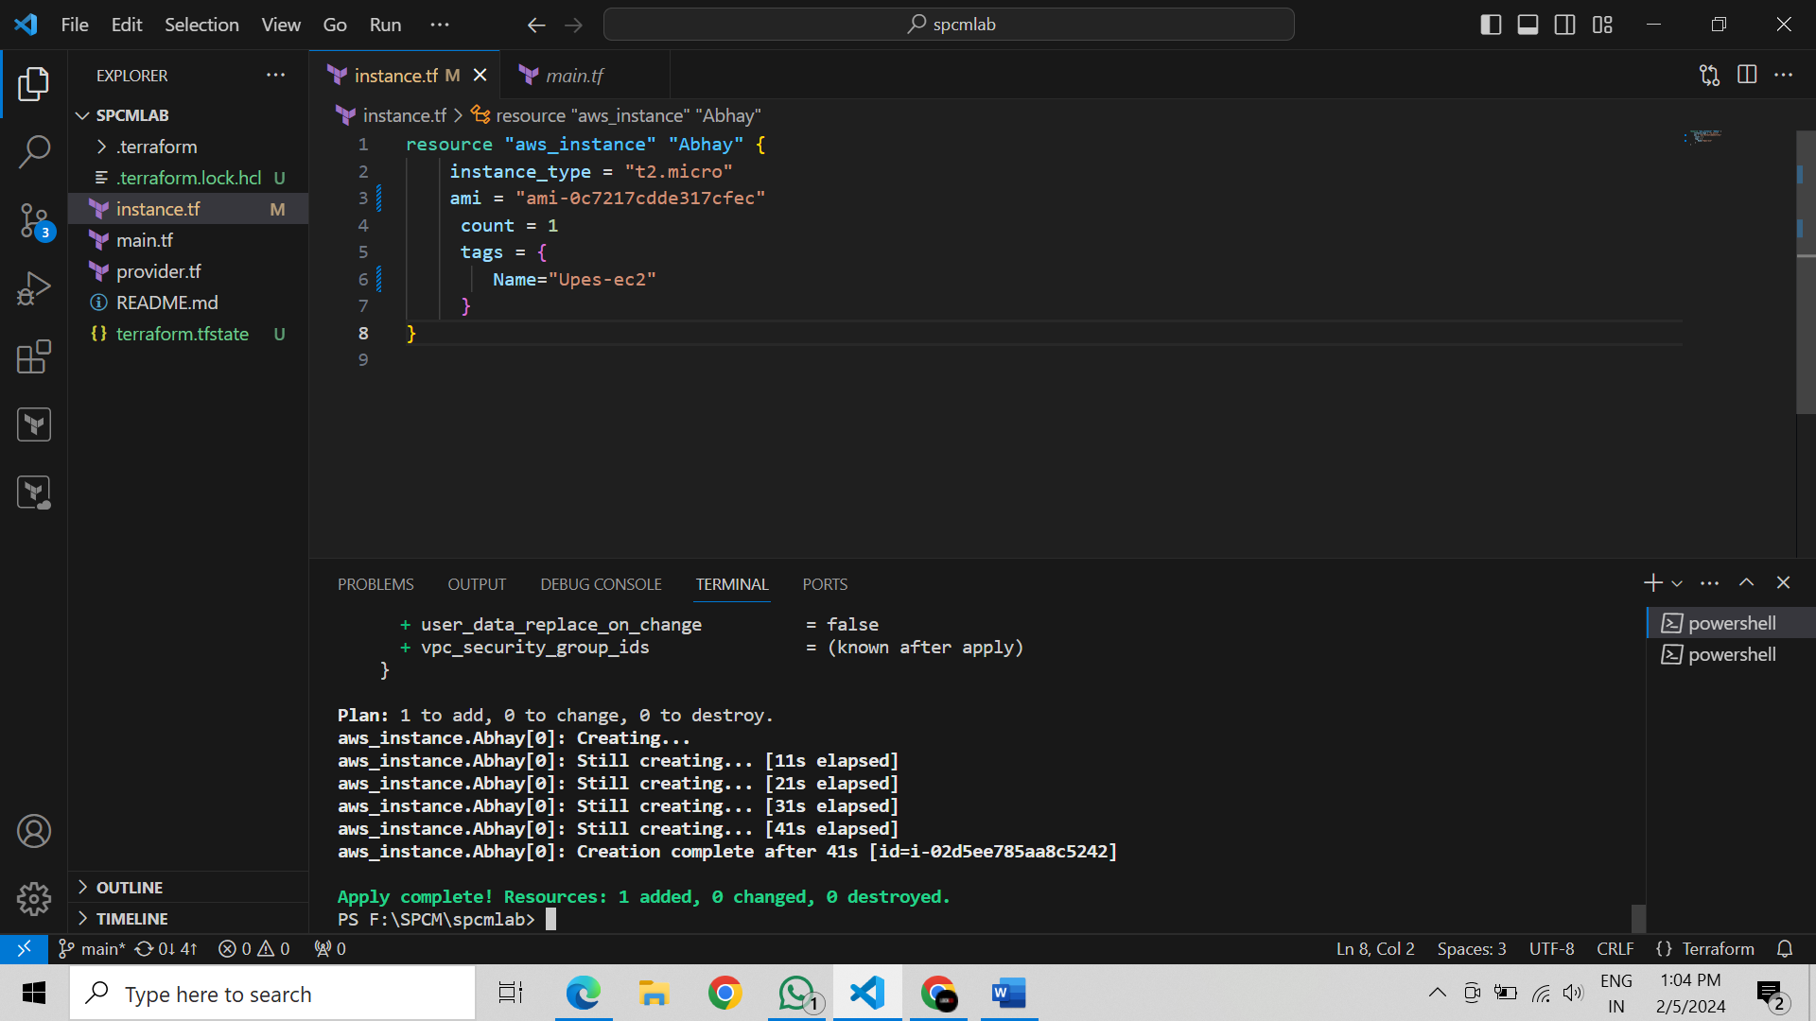

Step 5: Review Plan: Run the following command to see what Terraform will do:

Review the plan to ensure it aligns with your expectations.

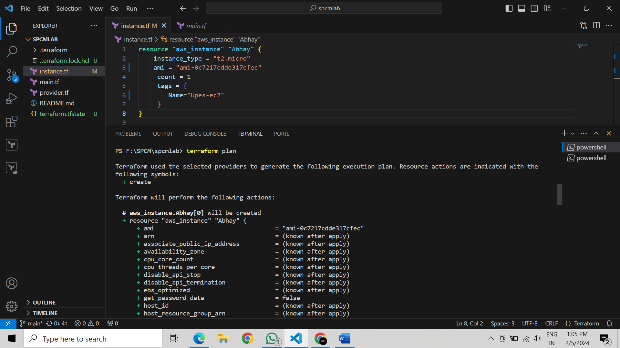

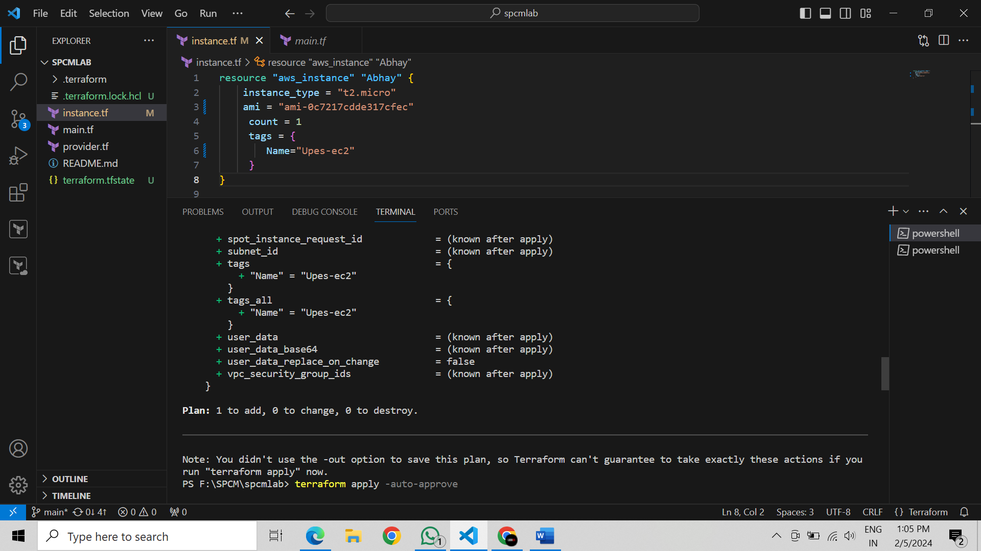

Step 6: Apply Changes: Apply the changes to create the AWS resources:

Type yes when prompted.

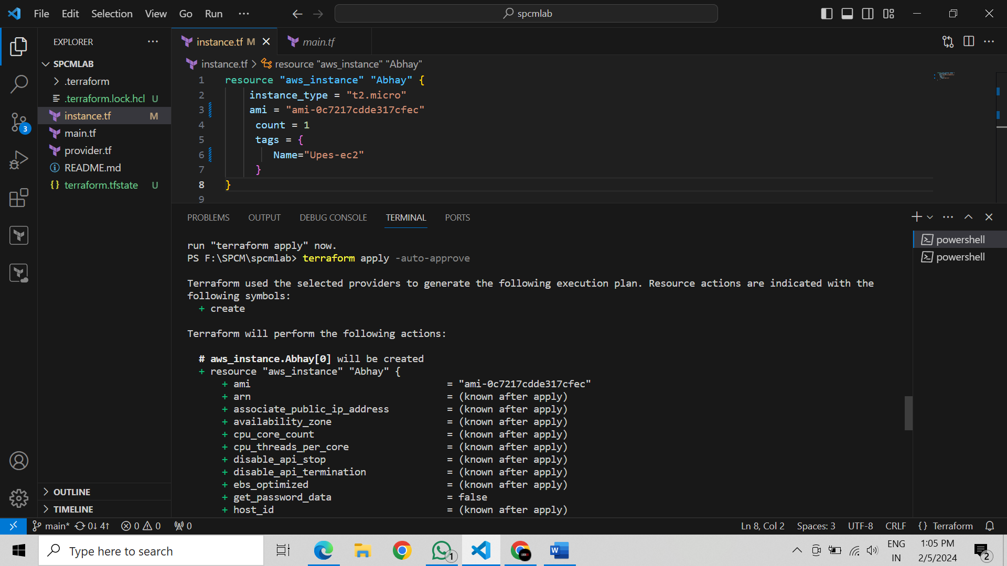

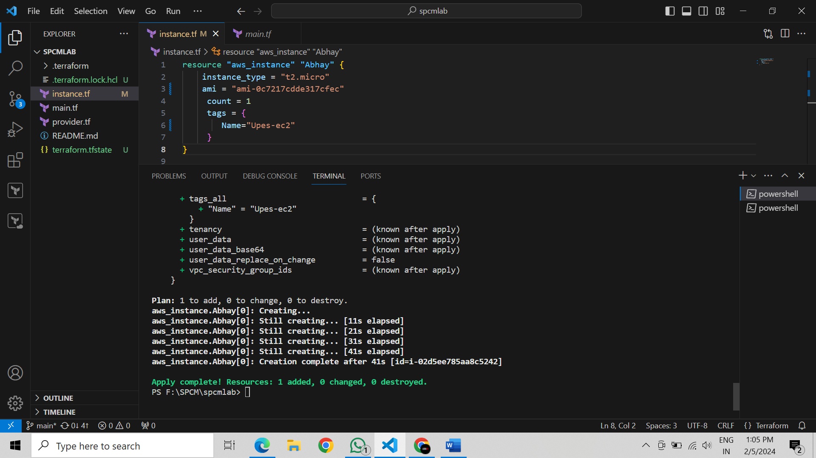

Step 7: Verify Resources: After the terraform apply command completes, log in to your AWS Management Console and navigate to the EC2 dashboard. Verify that the EC2 instance has been created.

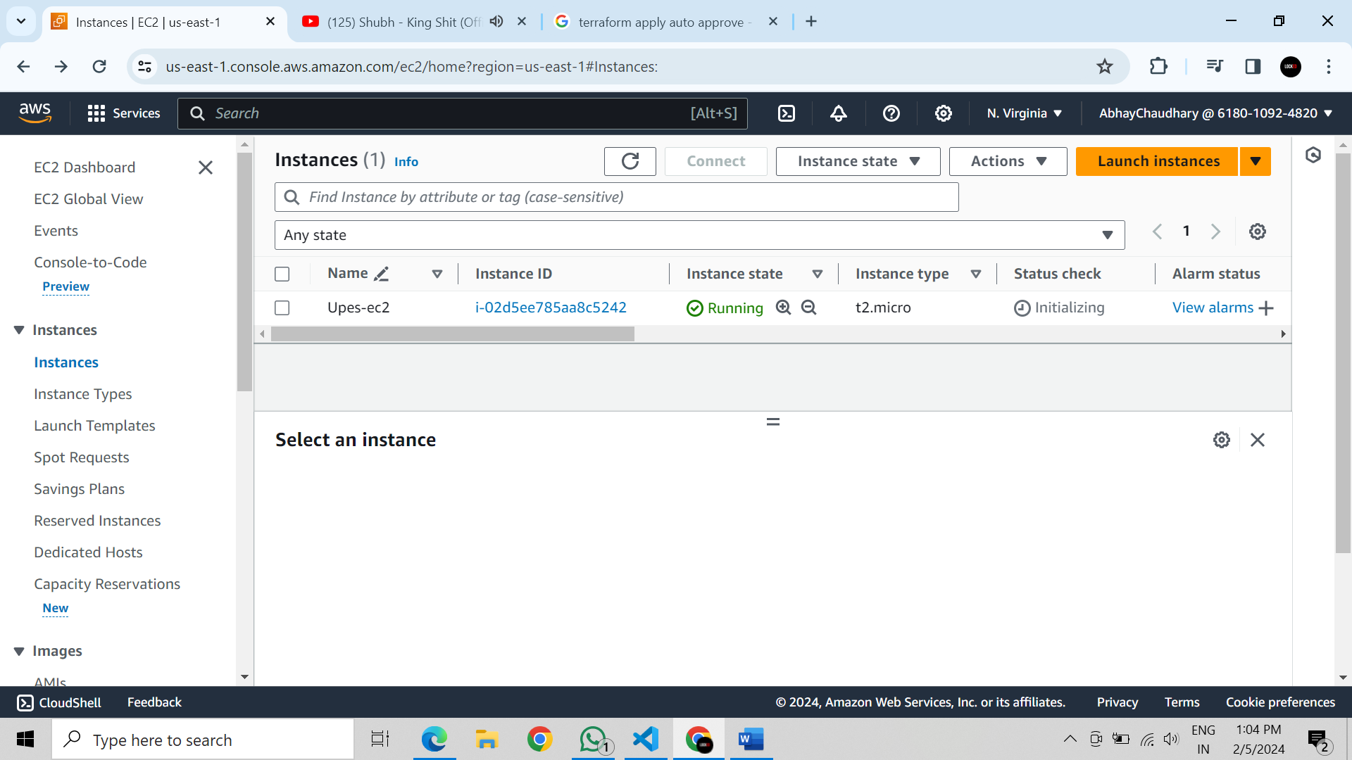

Step 8: Cleanup Resources: When you are done experimenting, run the following command to destroy the created resources:

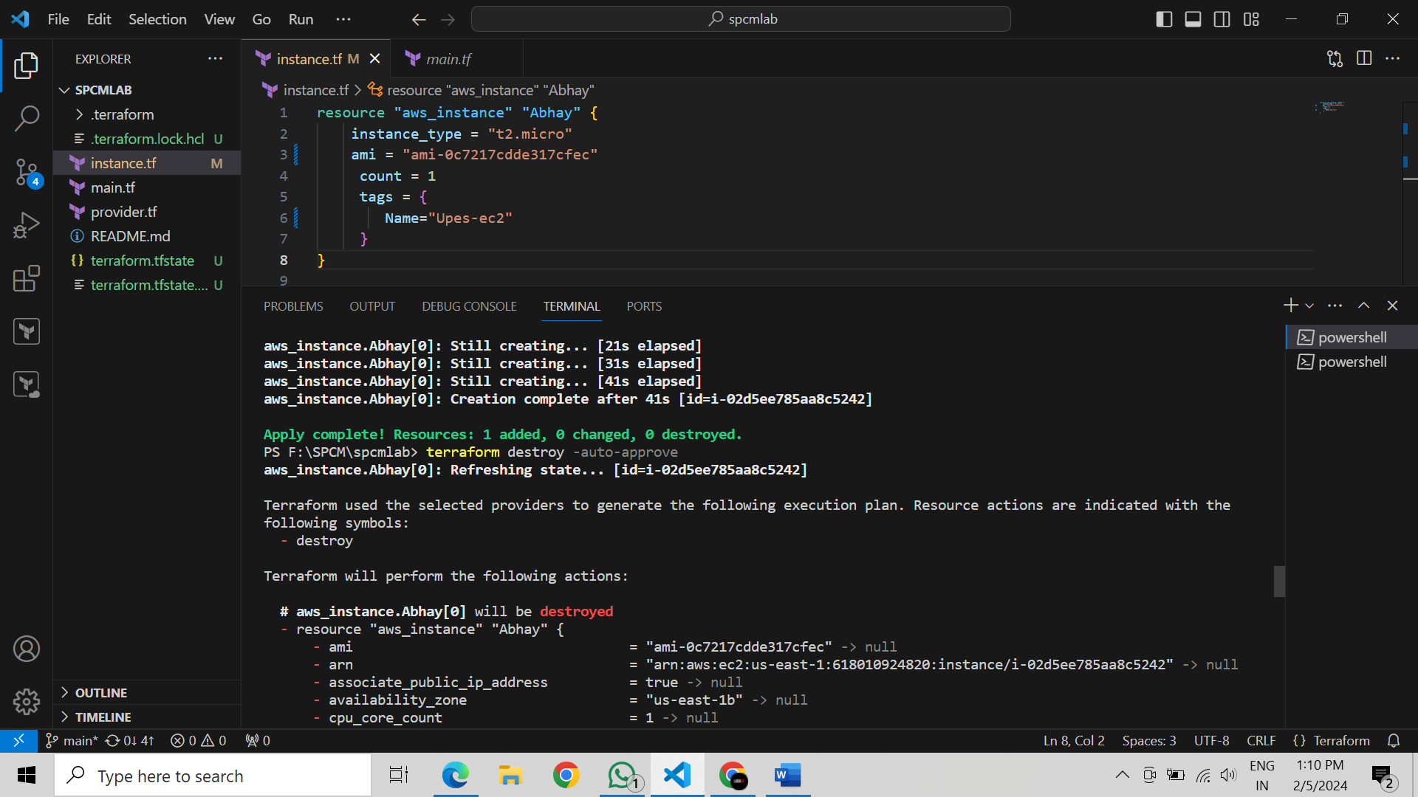

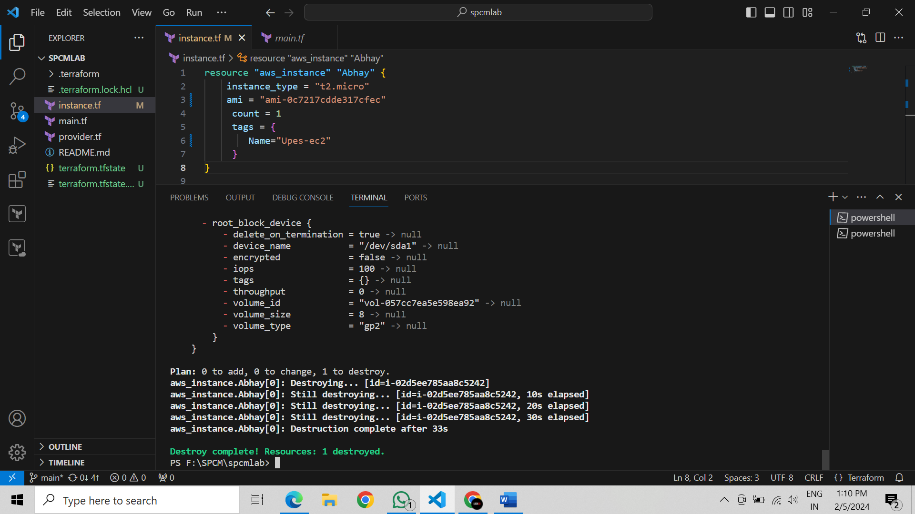

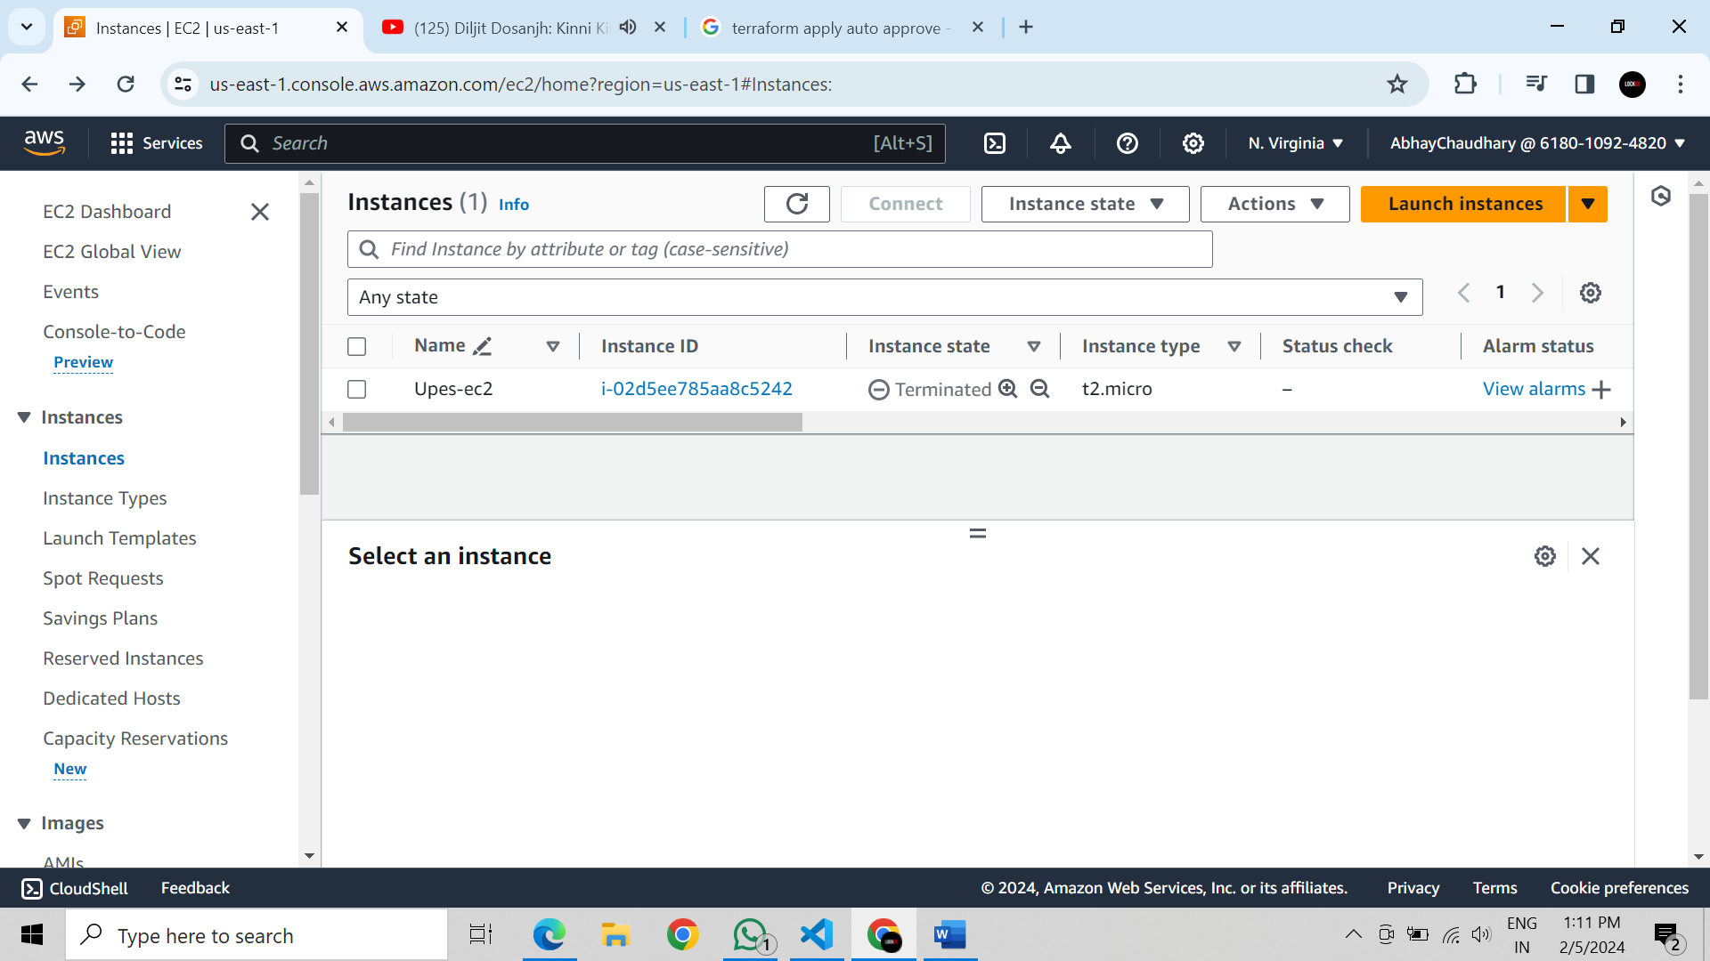

**Lab Exercise 4– Terraform Variables**

Objective: Learn how to define and use variables in Terraform configuration.

Steps: 1. Create a Terraform Directory:

• Create a new directory for your Terraform project.

2. Create a Terraform Configuration File:

• Create a file named main.tf within your project directory. # main.tf

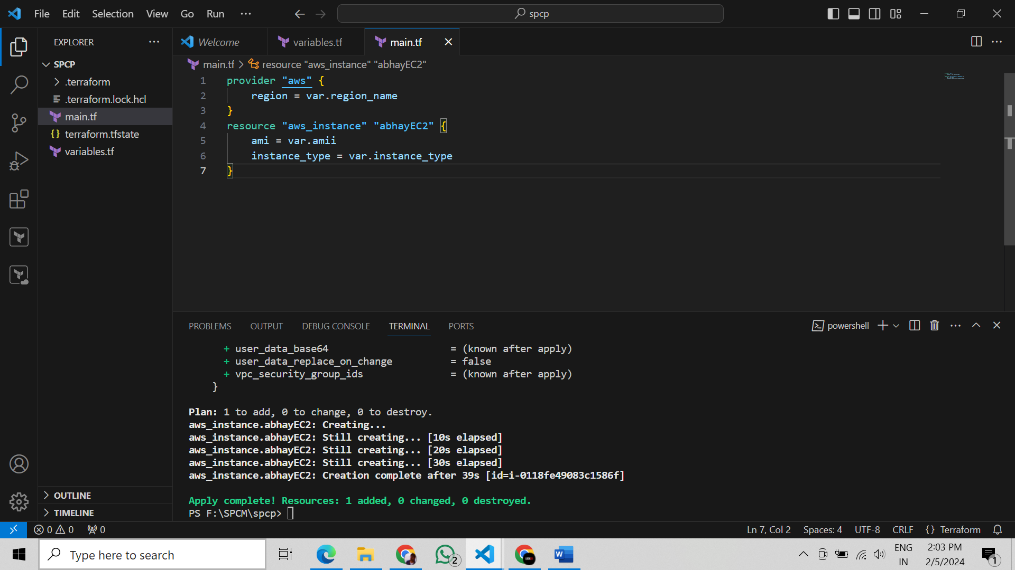

3. Define Variables: • Open a new file named variables.tf. Define variables for region, ami, and instance_type. # variables.tf

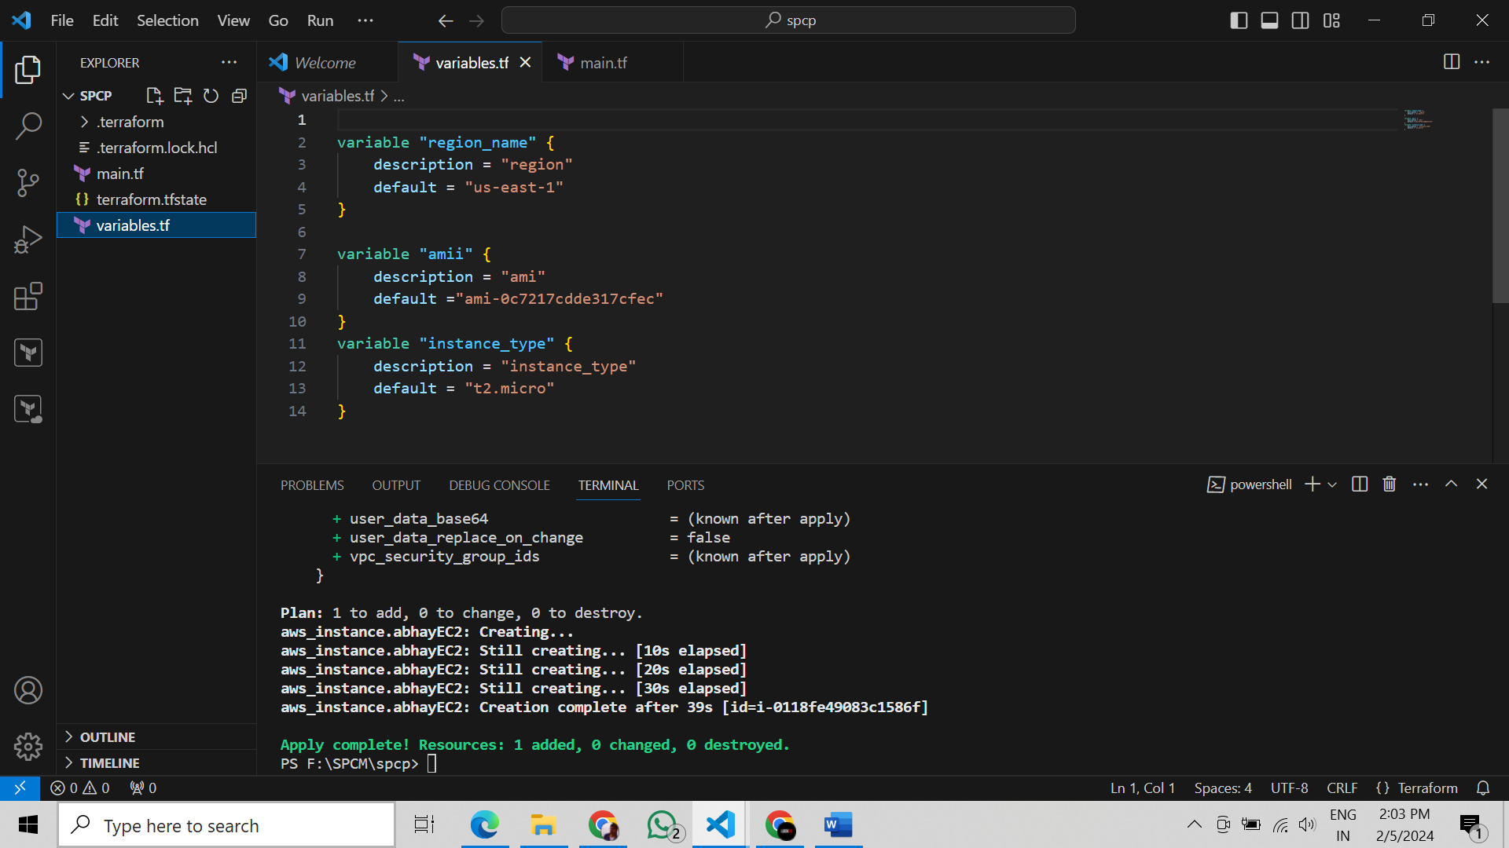

4. Use Variables in main.tf: • Modify main.tf to use the variables. # main.tf

5. Initialize and Apply: • Run the following Terraform commands to initialize and apply the configuration.

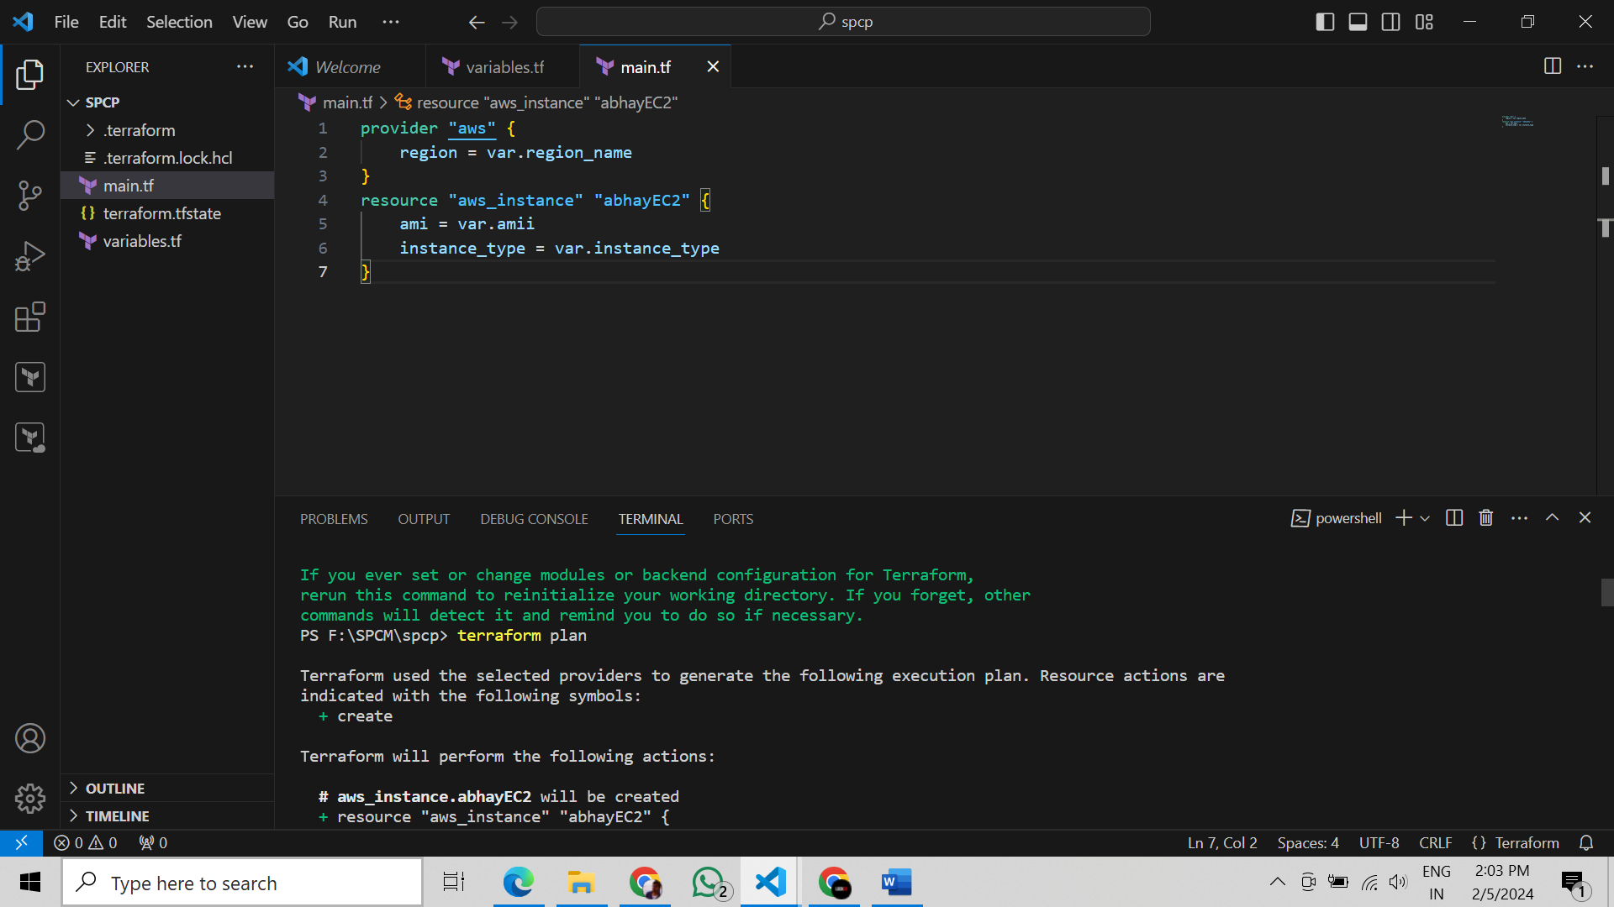

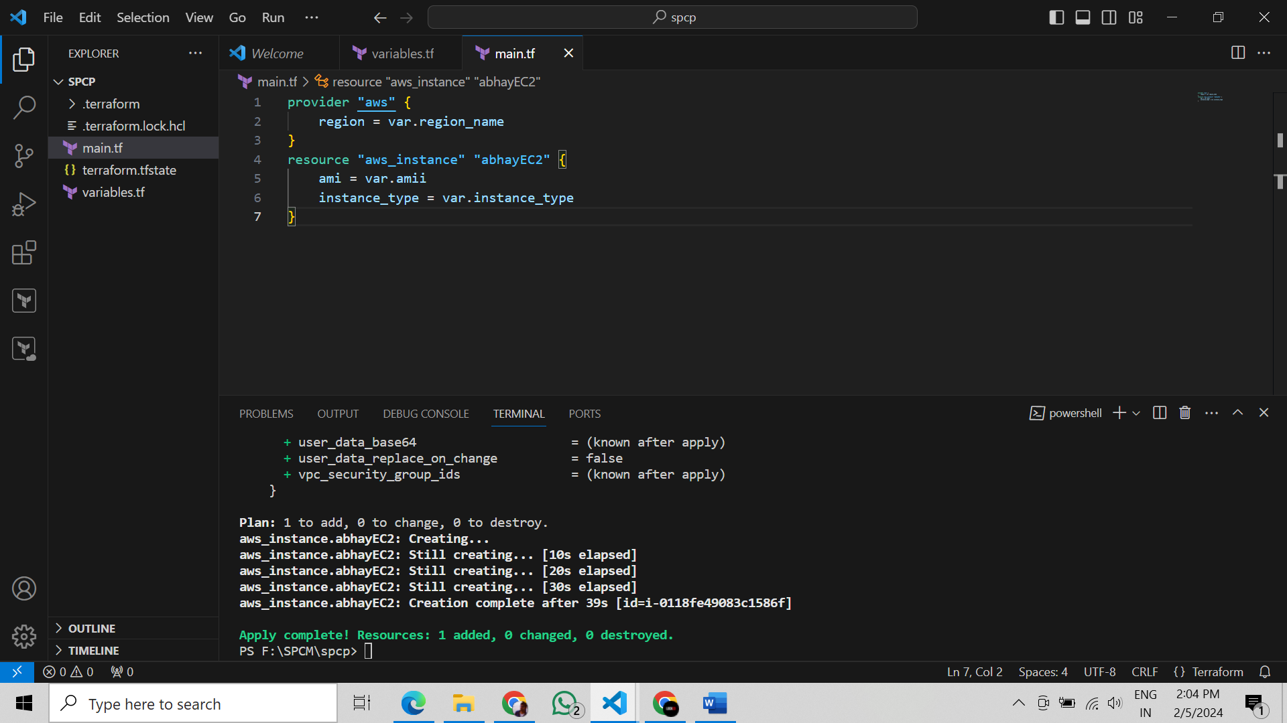

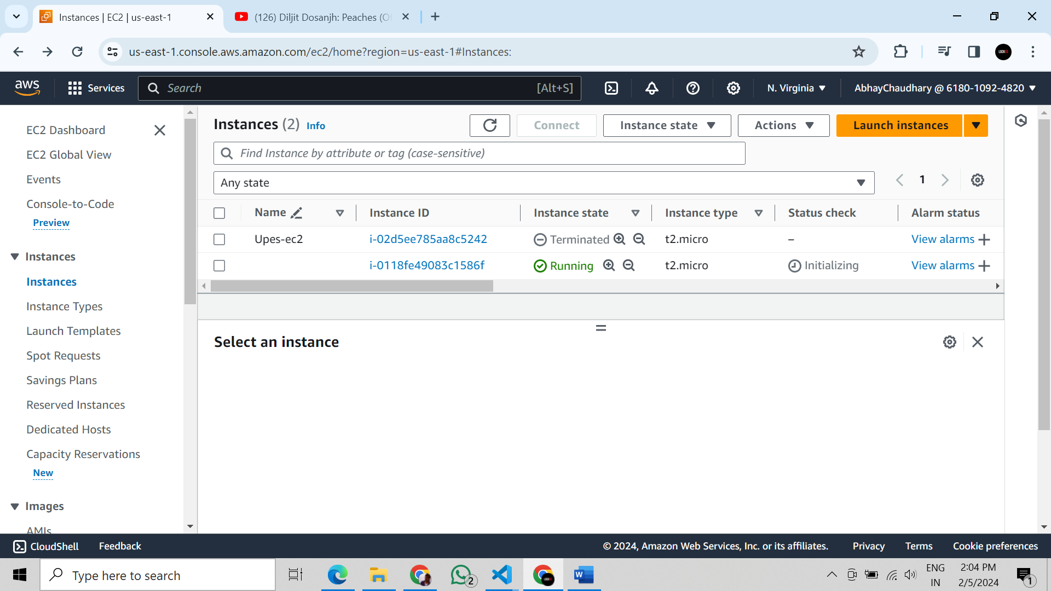

Observe how the region changes based on the variable override.

6. Clean Up: After testing, you can clean up resources.

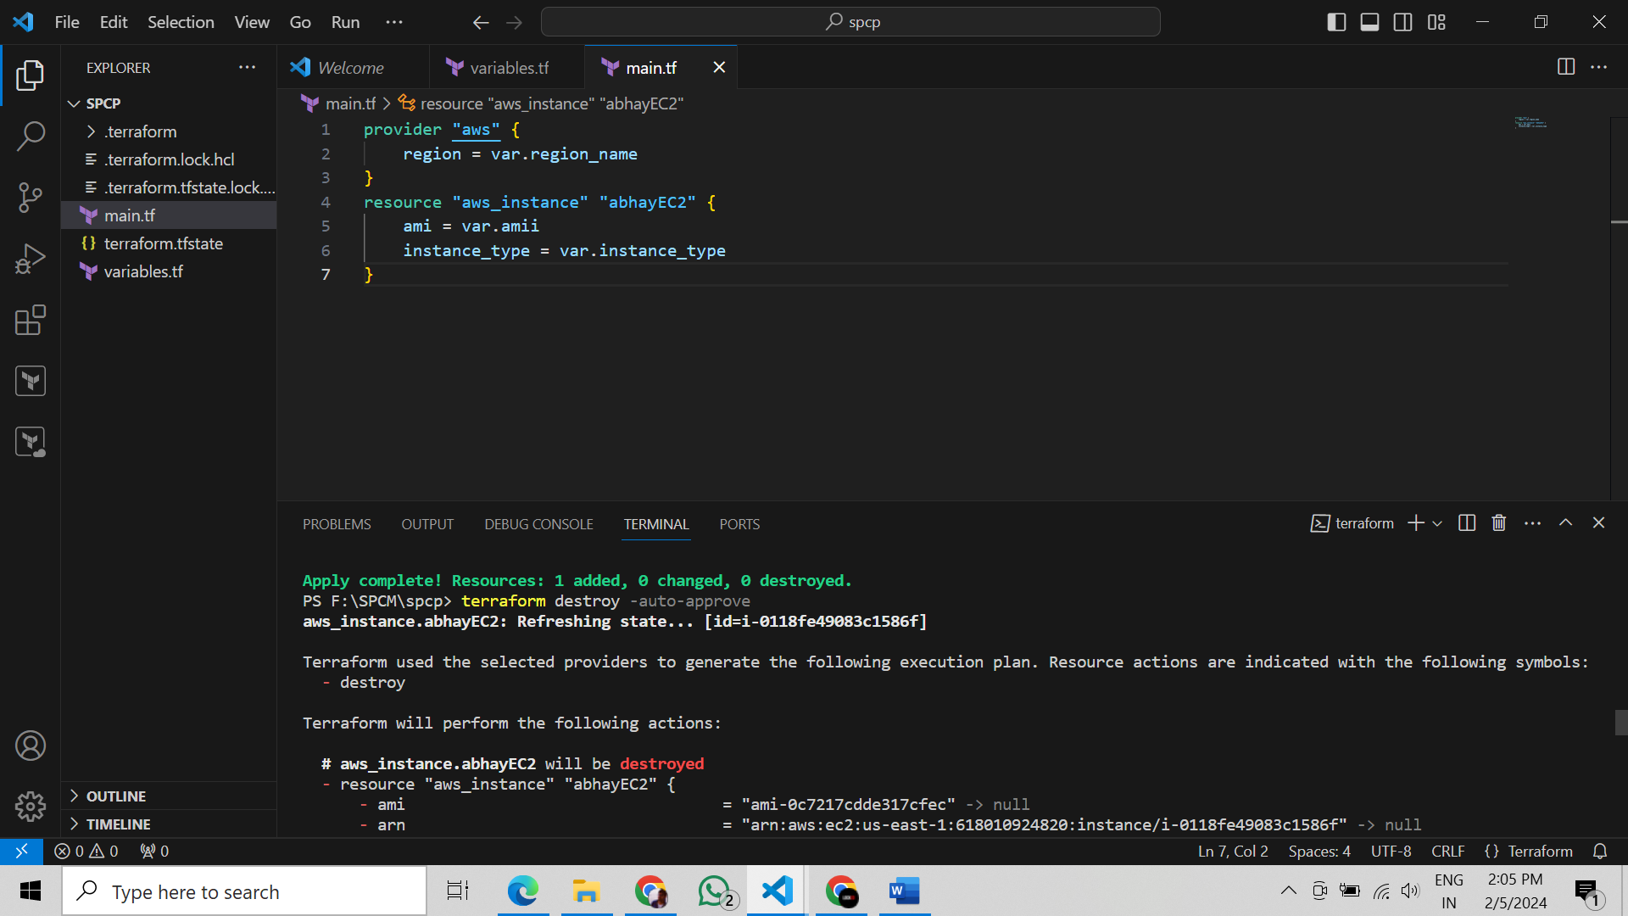

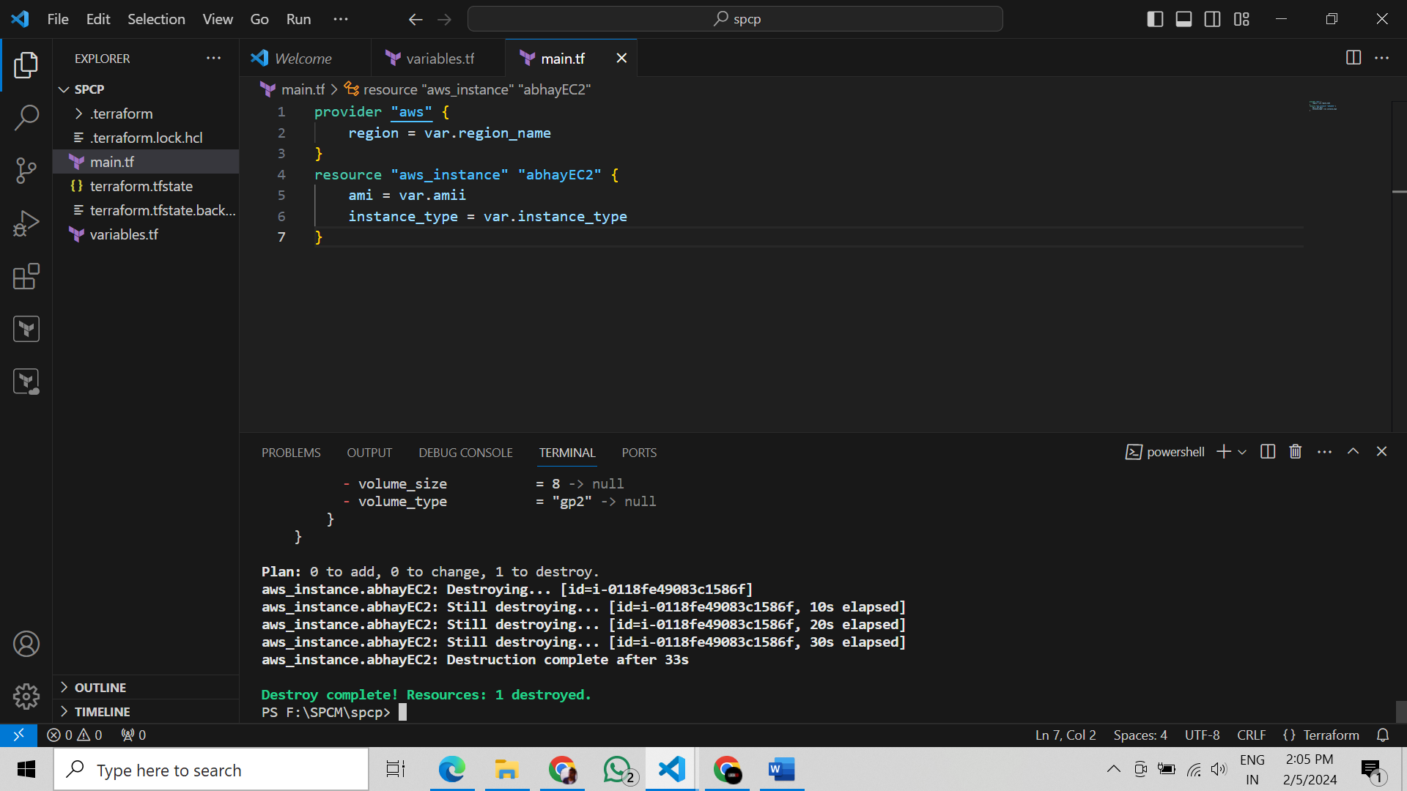 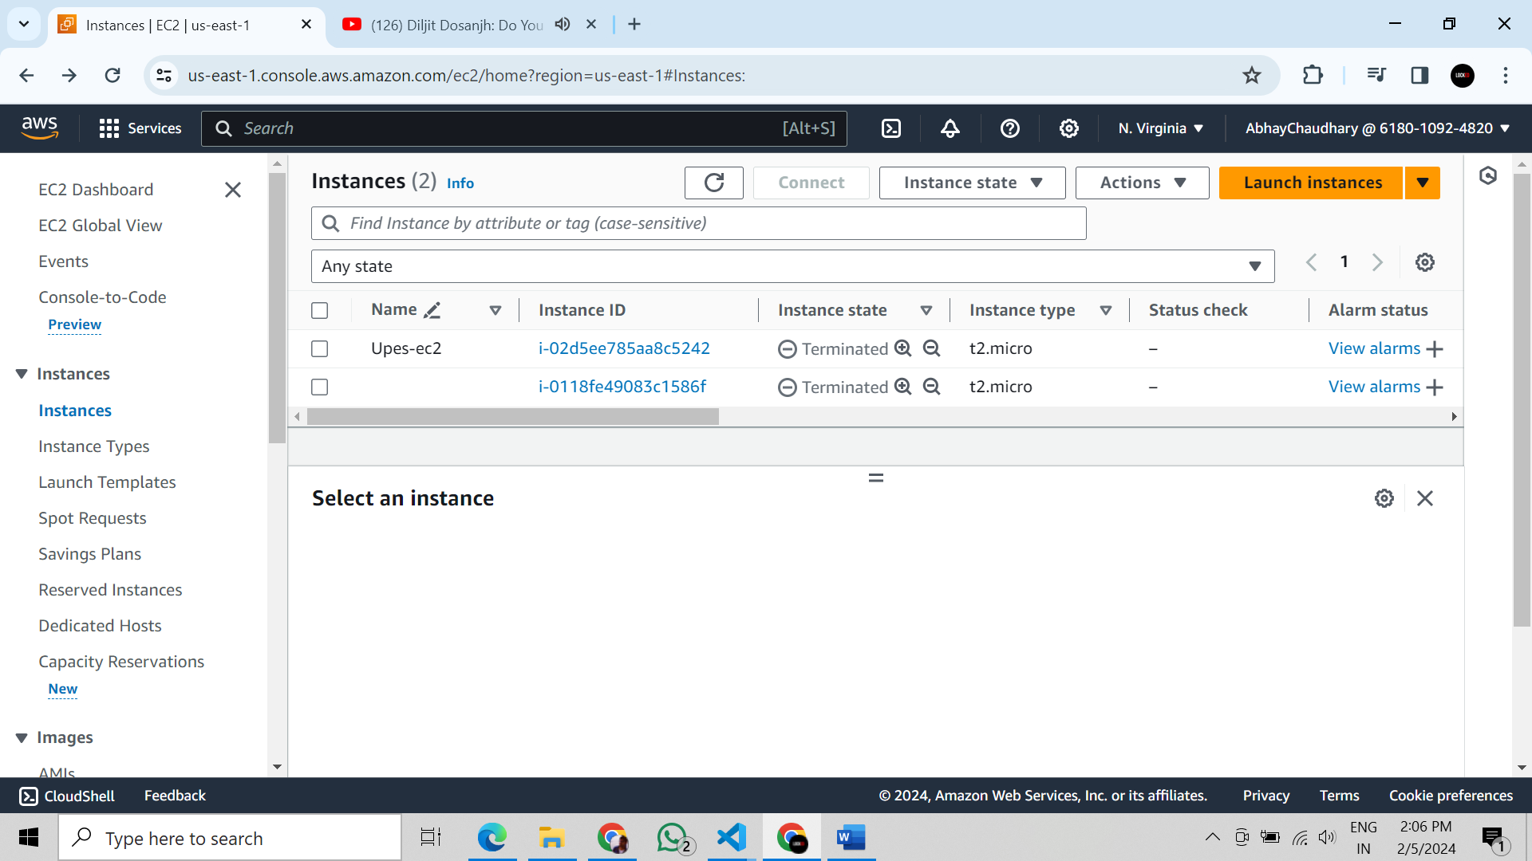

**Lab Exercise 5– Terraform Variables with Command Line Arguments**

. Use Command Line Arguments: • Open a terminal and navigate to your Terraform project directory. • Run the terraform init command:

Run the terraform apply command with command line arguments to set variable values:

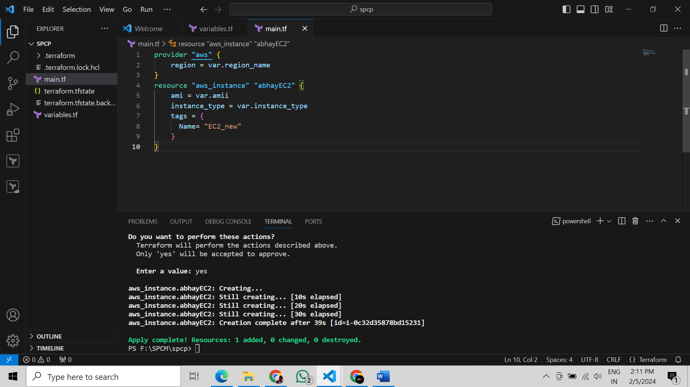 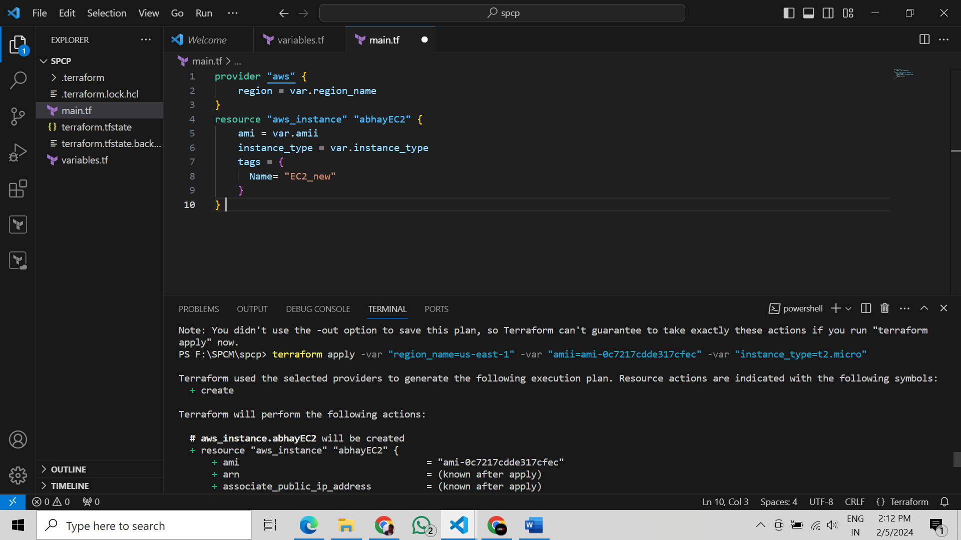 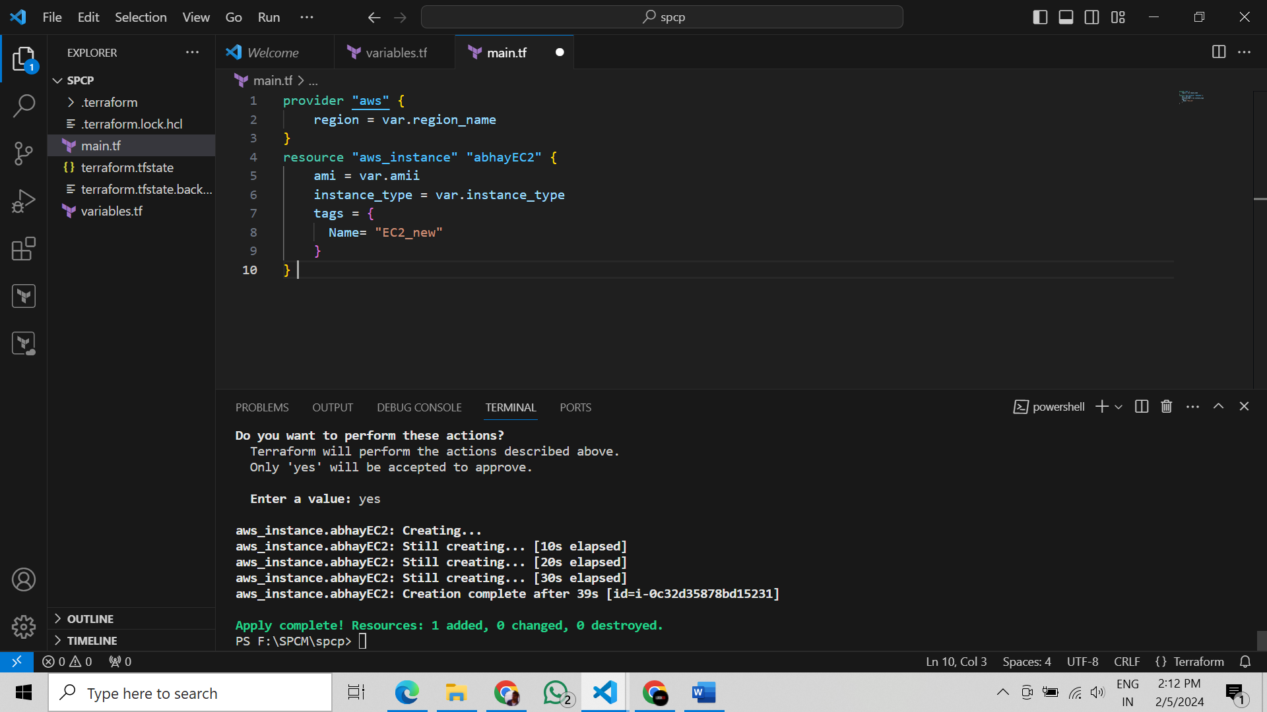 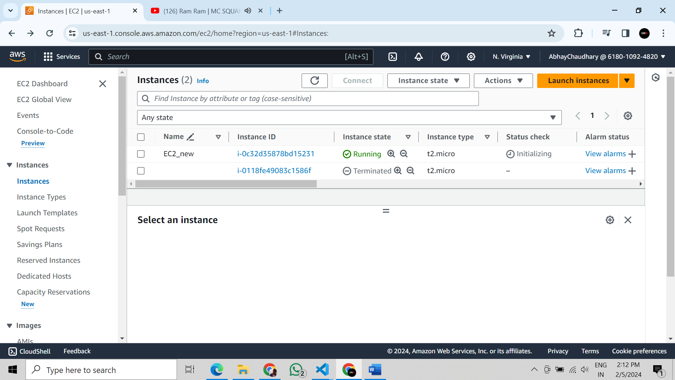

Clean Up: After testing, you can clean up resources:

